MY

SAFETY

PLAN

NAME: _______________________

CREATED BY GALLERY OF HOPE – WWW.GALLERYOFHOPE.ME

CRISIS CENTER CONTACTS

PHONE – DIAL 988 OR 1-800-273-8255 (TALK)

TELÉFONO - AYUDA SUICIDA EN ESPAÑOL - 1-888-628-9454 TEXTO AYUDA AL 741741

TEXT – 741741 (SEND A TEXT OR JUST ONE WORD LIKE: “HELP”, “TALK”, OR “HOME”)

CHAT – WWW.988LIFELINE.ORG OR WWW.CRISISTEXTLINE.ORG

OTHER: ___________________________________________________

OTHER: ___________________________________________________

OTHER CONTACTS

MENTAL HEALTH PROFESSIONAL: __________________________________
________________________________________________________
________________________________________________________

DOCTOR/PRIMARY CARE PHYSICIAN: ________________________________
________________________________________________________
________________________________________________________

OTHER: ___________________________________________________
________________________________________________________
________________________________________________________

OTHER: ___________________________________________________
________________________________________________________
________________________________________________________

OTHER: ___________________________________________________
________________________________________________________
________________________________________________________

OTHER: ___________________________________________________
________________________________________________________
________________________________________________________

INFORMATIVE WEBSITES

WWW.988LIFELINE.ORG, WWW.CRISISTEXTLINE.ORG, WWW.SUICIDE.ORG,

WWW.NAMI.ORG, WWW.AFSP.ORG, WWW.RESPONDERSTRONG.ORG, WWW.NVFC.ORG,

WWW.VETERANSCRISISLINE.NET, WWW.LINESFORLIFE.ORG, WWW.GALLERYOFHOPE.ME

CREATED BY GALLERY OF HOPE – WWW.GALLERYOFHOPE.ME

WHAT ARE MY NEEDS?

1. ______________________________________________________
2. ______________________________________________________
3. ______________________________________________________
4. ______________________________________________________
5. ______________________________________________________
6. ______________________________________________________

SUPPORT TEAM CONTACTS: NAME, ADDRESS, PHONE NUMBERS
(PEOPLE OR PERSON I CONFIDED IN WHO AGREED TO BE THERE TO HELP ME STAY SAFE)

1. _______________________________________________________
________________________________________________________
THIS PERSON WILL HELP BY: ______________________________________

2. _______________________________________________________
________________________________________________________
THIS PERSON WILL HELP BY: ______________________________________

3. _______________________________________________________
________________________________________________________
THIS PERSON WILL HELP BY: ______________________________________

4. _______________________________________________________
________________________________________________________
THIS PERSON WILL HELP BY: ______________________________________

5. _______________________________________________________
________________________________________________________
THIS PERSON WILL HELP BY: ______________________________________

I’M NOT GOING TO ACT ON MY SUICIDAL THOUGHTS!

I MATTER! I’M ENOUGH! I’M LOVED! I WILL LIVE!

CREATED BY GALLERY OF HOPE – WWW.GALLERYOFHOPE.ME
TO HELP ME BETTER UNDERSTAND MY SUICIDAL THINKING
I WILL ANSWER THESE QUESTIONS THOUGHTFULLY AND THE BEST I CAN

- WHAT CAUSES ME TO THINK ABOUT WANTING TO KILL MYSELF?
(LIST THE SPECIFIC STRESSOR(S), EVENT, PERSON/PEOPLE, ILLNESS, ETC)

- HOW HAVE I TRIED DEALING WITH OR SOLVING THE ABOVE CAUSE(S)?

- HOW DID I REACH THIS POINT? WHY HAS SUICIDE BECOME MY WAY OUT/SOLUTION?

- DO I REALLY WANT TO DIE? HOW DO I FEEL ABOUT ENDING MY LIFE?

- HAVE I NOTICED ANY WARNING SIGNS THAT HAPPEN BEFORE SUICIDAL THOUGHTS OCCUR OR INCREASE?

- DO I HAVE A PLAN ON HOW I WILL KILL MYSELF? IF SO, HOW?

- WHAT ITEMS AM I MOST LIKELY TO USE FOR HARMING MYSELF? HOW CAN I SAFELY REMOVE THEM? IF NEEDED - WHO CAN I CALL TO HELP REMOVE THEM?

- LIST ANYTHING I HAVE NOTICED THAT HELPS IN REDUCING MY SUICIDAL THINKING:

I CAN AND WILL GET THROUGH THIS! I’M NEEDED! I’M AMAZING!

CREATED BY GALLERY OF HOPE – WWW.GALLERYOFHOPE.ME
THINGS I CAN DO TO DISTRACT MY THOUGHTS

- WHAT ACTIVITIES CAN I DO BY MYSELF WHEN THOUGHTS OF SUICIDE APPEAR?
(INCLUDE THINGS I ENJOY DOING - NOW OR IN THE PAST)

- WHAT ACTIVITIES CAN I DO WITH OTHERS WHEN THOUGHTS OF SUICIDE APPEAR?

- WHAT NEW POSITIVE ACTIVITIES AM I WILLING TO TRY?

- PHRASES I CAN USE TO TURN NEGATIVE THOUGHTS INTO POSITIVE THINKING:

- WHAT POSITIVE PEOPLE CAN I VISIT OR HANG OUT WITH IN PERSON/ONLINE/PHONE?

- WHAT ARE MY REASONS FOR LIVING? (THINK ABOUT THIS OFTEN)

- WHAT GIVES ME HOPE, PURPOSE TO LIVE, OR ANY GOOD MEMORIES?

I’M NOT DYING TODAY! I’M MAKING IT THROUGH ANOTHER DAY!

CREATED BY GALLERY OF HOPE – WWW.GALLERYOFHOPE.ME
INSPIRING RESOURCE MATERIALS CREATED BY GALLERY OF HOPE

LOOK THROUGH MATERIALS THAT GALLERY OF HOPE HAS CREATED LIKE THE HEART OF HOPE DISTRACTION PLAN AND ADD FORMS TO THIS PLAN THAT MAY AIDE IN HEALING.

GALLERY OF HOPE’S HEART OF HOPE DISTRACTION RESOURCES PLAN
HAS MANY FORMS TO CHOOSE FROM
TO AID IN HELPING TO HEAL FROM SYMPTOMS AND GETTING NEEDS MET.
TOPICS INCLUDE NEEDS, HURTS, DISTRACTIONS, RELAXATION, ACCEPTANCE,
THINGS TO LEARN ABOUT MYSELF, CHANGING THOUGHTS, AND RESOURCES.

GALLERY OF HOPE’S
SNOWFLAKE MODEL
FOR HELPING
TO HEAL HURTS
AND OTHER USES.

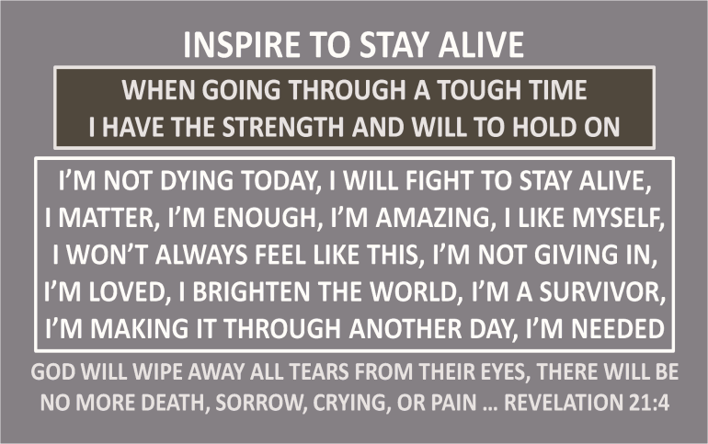
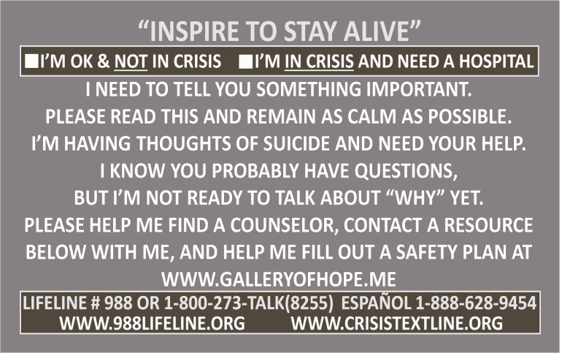

CREATED BY GALLERY OF HOPE – WWW.GALLERYOFHOPE.ME
15 STEPS I WILL DO TO HELP KEEP MYSELF ALIVE

01. I WILL REMOVE ANY TEMPTING ITEMS THAT CAN BE USED TO HURT MYSELF, OR
GET SOMEONE TO REMOVE THEM FOR ME.

02. I WILL THOUGHTFULLY FILL OUT MY SAFETY PLAN & OTHER RESOURCE MATERIALS.

03. TO THE BEST OF MY ABILITY I WILL AVOID WHAT CAUSES SUICIDAL THINKING.

04. WHEN NEGATIVE THOUGHTS APPEAR, I WILL REPLACE THEM WITH POSITIVE ONES.

05. I WILL LEARN ABOUT MYSELF INCLUDING WHAT MY WARNING SIGNS ARE.

06. I WILL RESPECT MY BODY. I WILL DO MY BEST TO: NOT HARM MYSELF, EXERCISE.
EAT HEALTHY, NOT ACT RECKLESS, AND STAY AWAY FROM ALCOHOL & DRUGS.

07. I WILL MAKE SURE CONTACT NUMBERS ARE IN MY PHONE AND WRITTEN DOWN.

08. I WILL PREPARE & BE READY TO FACE ANY CHALLENGING DAY/EVENT LIFE BRINGS.

09. I WILL KEEP MY MIND BUSY, DO POSITIVE ACTIVITIES, AND STAY IN THE MOMENT.

10. I WILL GO PLACES TO DISTRACT MYSELF/STAY HOME FOCUSING ON RELAXATION.

11. I WILL VISIT/SOCIALIZE WITH POSITIVE PEOPLE (IN PERSON, PHONE, OR ONLINE).

12. I WILL HOLD ONTO WHAT GIVES ME HOPE AND REASON TO LIVE.

13. WHEN FEELING DOWN MORE THAN USUAL, I WILL USE MY SAFETY PLAN TO:

CONTACT PEOPLE ON MY SUPPORT TEAM, DO DISTRACTION ACTIVITIES, MAKE

A MENTAL HEALTH APPOINTMENT.

14. WHEN WARNING SIGNS ARE PRESENT AND THESE STEPS ARE NOT WORKING:
TO REMAIN SAFE I WILL CALL A CRISIS LINE/MY MENTAL HEALTH PROVIDER,
OR GO TO A HOSPITAL EMERGENCY ROOM.

15. I WILL HELP OTHERS. I WILL FIND LITTLE WAYS TO SHOW OTHERS JOY/KINDNESS.
HELPING OTHERS OR DOING SOMETHING NICE, MAY HELP ME FEEL BETTER.

16. OPTIONAL: I WILL ADD FORMS FROM THE HEART OF HOPE DISTRACTION PLAN OR
OTHER FORMS GALLERY OF HOPE HAS CREATED TO MY SAFETY PLAN.

I’M IN CHARGE OF MY LIFE & THOUGHTS! I WILL FIGHT TO STAY ALIVE!

CREATED BY GALLERY OF HOPE – WWW.GALLERYOFHOPE.ME
